**SOLUTION IMPLEMENTATION CHANGE**

1. **Requirement change development.**

“Regarding the technical implementation following is suggested:

1.      Have all Order Cubes (OI, TO and OB) in two versions

a.      First Version with Pre-calculated values ONLY, so always pre-calc., even if post-calc. is available

b.      Second Version with “most up to date” values, so take post-calc. if available and pre-calc. if there is no post-calc

i.     These Cubes should contain an additional Entity “Calculation Status” indicating whether the Order is “Pre-calc.” or “Post-calc.” (naming is just a suggestion)

So, establish a new Entity “Calculation Status” as well as building up all order data cubes in twice.”

1. **Clarification Requirement Change Development**

* Development change only impacts on logical data of two tables that are FAKT_OrderComplete table and FAKT_OrderComplete_DB2 table. Because the distinction data in (ordercomplete_value and ordercomplete_value_DB2) is not yet clear and don’t know those values belong to Pre-calculation or Post-Calculation
* Board layer : will be had new two version

The first version : with Pre-calculated values ONLY, so always pre-calc., even if post-calc. is available

The Second Version : take post-calc

Between two version will be distinguished by calculation_status

1. **Evaluation of Current System**
   1. Board
   2. DWH
      1. Context Diagram LoadToFact

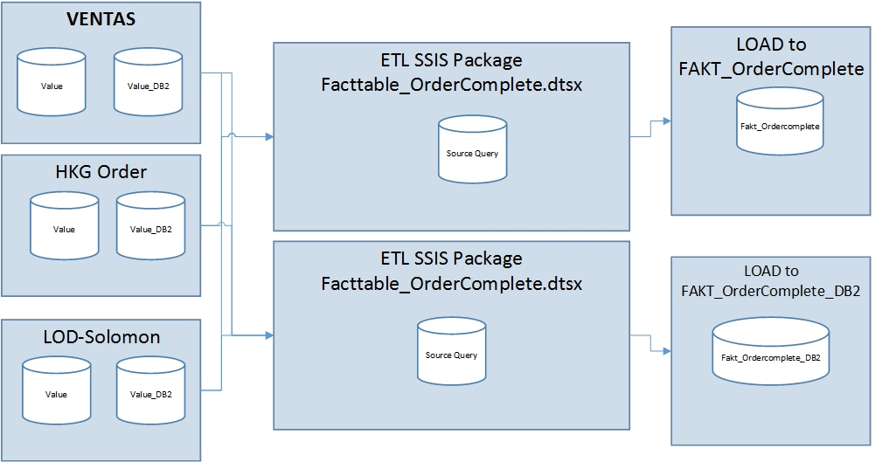

* + 1. Structure Table and View
* Table FAKT_OrderComplete

[ordercomplete_value] Field is stored the final value of Order

[ordercomplete_value_currency] Field is stored the final value_currency of Order

[ordercomplete_db2] Field

[ordercomplete_db2_currency] Field

* Current Mapping:
* **Ventas:Ventas_Ordercomplete_trade_value**

Preis_ges_dm🡪ordercomplete_value

Preis_ges_wr🡪ordercomplete_value_currency

Ignore🡪 ordercomplete_db2

Ignore🡪 ordercomplete_db2_currency

* **Ventas:Ventas_Ordercomplete_commision_Value**

Preis_ges_dm🡪ordercomplete_value

Preis_ges_wr🡪ordercomplete_value_currency

Ignore🡪 ordercomplete_db2

Ignore🡪 ordercomplete_db2_currency

* **LOD-Solomon: Non HKG orders and FOXPRO orders before 2013 - Fact Order Complete**

ordercomplete_value 🡪ordercomplete_value

ordercomplete_value_currency 🡪ordercomplete_value_currency

Ignore🡪 ordercomplete_db2

Ignore🡪 ordercomplete_db2_currency

* **LOD-Solomon: HKG orders and FOXPRO orders since 2013 - Fact Order Complete**

ordercomplete_value 🡪ordercomplete_value

ordercomplete_value_currency 🡪ordercomplete_value_currency

Ignore🡪 ordercomplete_db2

Ignore🡪 ordercomplete_db2_currency

* **Local-Orders: Local Orders_OrderComplete_Value**

Wert_Wrg 🡪ordercomplete_value

Ignore 🡪ordercomplete_value_currency

Ignore🡪 ordercomplete_db2

Ignore🡪 ordercomplete_db2_currency

* Table FAKT_OrderComplete_DB2

[ordercomplete_value] Field

[ordercomplete_value_currency] Field

[ordercomplete_db2] Field is stored the final value_db2 of order

[ordercomplete_db3] Field is stored the final value_db3 of order

[ordercomplete_db2_currency] Field is store the final value_db2_currency of order

* Mapping :
* **Ventas:Ventas_Ordercomplete_trade_value**

Ignore 🡪ordercomplete_value

Ignore 🡪ordercomplete_value_currency

DB2🡪 ordercomplete_db2

Ignore🡪 ordercomplete_db2_currency

Ignore🡪 ordercomplete_db3

* **Ventas:Ventas_Ordercomplete_commision_Value**

Ignore 🡪ordercomplete_value

Ignore 🡪ordercomplete_value_currency

DB2🡪 ordercomplete_db2

Ignore🡪 ordercomplete_db2_currency

Ignore🡪 ordercomplete_db3

* **LOD-solomon: Non HKG orders and FOXPRO orders before 2013 - Fact Order Complete**

Ignore 🡪ordercomplete_value

Ignore 🡪ordercomplete_value_currency

ordercomplete_db2🡪 ordercomplete_db2

Ignore🡪 ordercomplete_db2_currency

ordercomplete_db3🡪 ordercomplete_db3

* **LOD-solomon: HKG orders and FOXPRO orders since 2013 - Fact Order Complete**

Ignore 🡪ordercomplete_value

Ignore 🡪ordercomplete_value_currency

ordercomplete_db2🡪 ordercomplete_db2

Ignore🡪 ordercomplete_db2_currency

ordercomplete_db3🡪 ordercomplete_db3

* **Local-Orders: Local Orders_OrderComplete_Value**

Ignore 🡪ordercomplete_value

Ignore 🡪ordercomplete_value_currency

DB2🡪 ordercomplete_db2

Ignore🡪 ordercomplete_db2_currency

Ignore 🡪 ordercomplete_db2

1. **Solution Development Change**
   1. Board
   2. DWH
      1. Staging Structure database.

Add new five columns into FAKT_OrderComplete and FAKT_OrderComplete_DB2. Don’t change or replace any current columns to ensure that System will be run fine and avoid largely impacts cannot handle in a short time

* FAKT_OrderComplete

[PreCal_Value] [money] NULL,

[PreCal_Value_Currency] [money] NULL,

[PostCal_Value] [money] NULL,

[PostCal_Value_Currency] [money] NULL,

[Calculation_Status] [bit] NULL

* FAKT_OrderComplete_DB2

[PreCal_Value_DB2] [money] NULL,

[PreCal_Value_DB3] [money] NULL,

[PostCal_Value_DB2] [money] NULL,

[PostCal_Value_DB3] [money] NULL,

[Calculation_Status] [bit] NULL

These views will be changed structure. In Fact, add new five columns in list of below views

* [dbo].[vTMP_VENTAS_OrderComplete_Comm_DB2pos]

In the first statement, we agreed that the Value DB2 is post-calculation. Just copying logic DB2 and then save as new columns Post_Value_DB2. Although this view has not contained PreCal_Value_DB2, PreCal_Value_DB3, PostCal_Value_DB3,[Calculation_Status] before, we add these columns in this view

'0' AS PreCal_Value_DB2,

'0' AS PreCal_Value_DB3,

SUM(c.b_betrag) * CASE

WHEN b.preis_ges_dm_ges = 0

THEN a.preis_ges_dm / (anz_pos * 1.0)

ELSE a.preis_ges_dm / b.preis_ges_dm_ges * 100

END / 100 AS PostCal_Value_DB2,

'0' AS PostCal_Value_DB3,

'1' AS [Calculation_Status],

In the second statement, We agreed that Value DB2 is Pre-calculation. Just copying logic DB2 and then save as new column PreCal_Value_DB2. Although this view has not contained PostCal_Value_DB2, PostCal_Value_DB3, PreCal_Value_DB3,[Calculation_Status] before, we add these columns in this view

b.db2 AS PreCal_Value_DB2,

'0' AS PreCal_Value_DB3,

'0' AS PostCal_Value_DB2,

'0' AS PostCal_Value_DB3,

'0' AS [Calculation_Status],

* [dbo].[vTMP_VENTAS_OrderComplete_Comm_Value]

We agreed that with commission Order only have pre-calculation.Just copying bbo.LZ_VENTAS_akpos.preis_ges_wr, dbo.LZ_VENTAS_akpos.preis_ges_dm and them save as PreCal_Value_Currency and PreCal_Value . Concurrently, add new columns PostCal_Value, PostCal_Value_Currency, [Calculation_Status]

* vTMP_VENTAS_OrderComplete_Trade_DB2pos

In the first statement , we agreed that the Value DB2 is post-calculation. Just copying logic DB2 and then save as new columns Post_Value_DB2 . Although this view has not contained PreCal_Value_DB2, PreCal_Value_DB3, PostCal_Value_DB3,[Calculation_Status] before, we add these columns in this view

'0' AS PreCal_Value_DB2,

'0' AS PreCal_Value_DB3,

SUM(c.b_betrag) * CASE

WHEN b.preis_ges_dm_ges = 0

THEN a.preis_ges_dm / (anz_pos * 1.0)

ELSE a.preis_ges_dm / b.preis_ges_dm_ges * 100

END / 100 AS PostCal_Value_DB2,

'0' AS PostCal_Value_DB3,

'1' AS [Calculation_Status],

In the second statement, We agreed that Value DB2 is Pre-calculation. Just copying logic DB2 and then save as new column PreCal_Value_DB2. Although this view has not contained PostCal_Value_DB2, PostCal_Value_DB3, PreCal_Value_DB3,[Calculation_Status] before, we add these columns in this view

b.db2 AS PreCal_Value_DB2,

'0' AS PreCal_Value_DB3,

'0' AS PostCal_Value_DB2,

'0' AS PostCal_Value_DB3,

'0' AS [Calculation_Status],

* vTMP_VENTAS_OrderComplete_Trade_Value

Don’t change logic calculation of two fields because two fields is used in another views so that we add new logic calculation to create new fields(PreCal_Value ,PreCal_Value_Currency , PostCal_Value_Currency , PostCal_Value, Calculation_Status ) which rely on two fields existing (preis_ges_wr, preis_ges_dm)

a.preis_ges_wr AS PreCal_Value_Currency,

a.preis_ges_dm AS PreCal_Value,

CASE

WHEN a.abgerechnet_dat IS NOT NULL

THEN b.preis_ges_wr

ELSE 0

END AS PostCal_Value_Currency,

CASE

WHEN a.abgerechnet_dat IS NOT NULL

THEN b.preis_ges_dm

ELSE 0

END AS PostCal_Value,

CASE

WHEN a.abgerechnet_dat IS NOT NULL

THEN 1

ELSE 0

END AS [Calculation_Status],

-- if abgrechnet_dat is null then order intake value else invoice values

CASE

WHEN a.abgerechnet_dat IS NULL

THEN a.preis_ges_wr

ELSE b.preis_ges_wr

END AS preis_ges_wr,

CASE

WHEN a.abgerechnet_dat IS NULL

THEN a.preis_ges_dm

ELSE b.preis_ges_dm

END AS preis_ges_dm,

* + 1. SSIS Package ETL

Change source query script to load data into FAKT_OrderComplete and edit mapping from source to destination of FAKT_OrderComplete_DB2

Source query FAKT_Complete

PreCal_Value 🡪 PreCal_Value

PreCal_Value_Currency 🡪 PreCal_Value_Currency

PostCal_Value 🡪 PostCal_Value

PostCal_Value_Currency 🡪 PostCal_Value_Currency

Calculation_Status 🡪 Calculation_Status

Change source query script to load data into FAKT_OrderComplete and edit mapping from source to destination of FAKT_OrderComplete_DB2

Source query FAKT_Complete _DB2

PreCal_Value_DB2, 🡪 PreCal_Value_DB2,

PreCal_Value_DB3 🡪 PreCal_Value_DB3

PostCal_Value_DB2 🡪 PostCal_Value_DB2

PostCal_Value_DB3 🡪 PostCal_Value_DB3

Calculation_Status 🡪 Calculation_Status

1. Implementation
   1. DWH
      1. Staging Structure Database

* Change Structure FAKT_OrderComplete table by adding new five columns

Old structure New structure

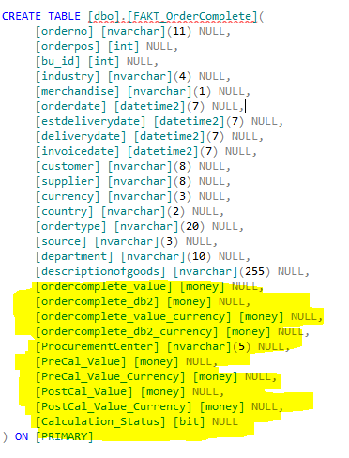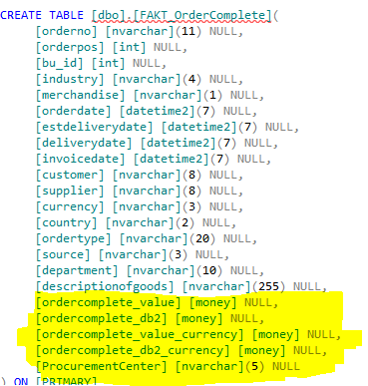

* Change structure FAKT_OrderComplete_DB2 table by adding new five columns

Old Structure New Structure

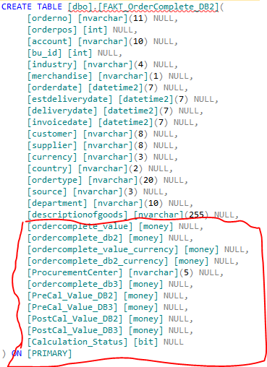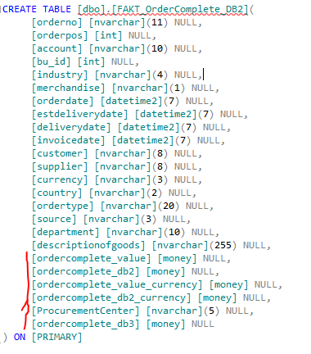

* Change Structure view [vTMP_VENTAS_OrderComplete_Comm_DB2pos]

Old Structure New Structure

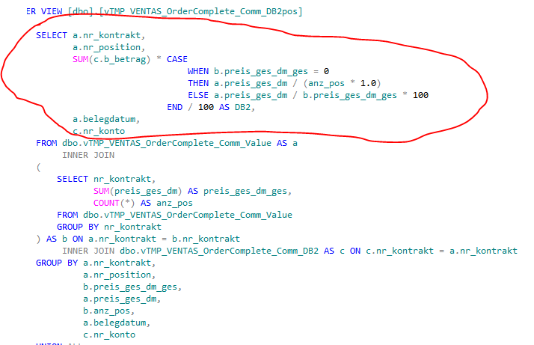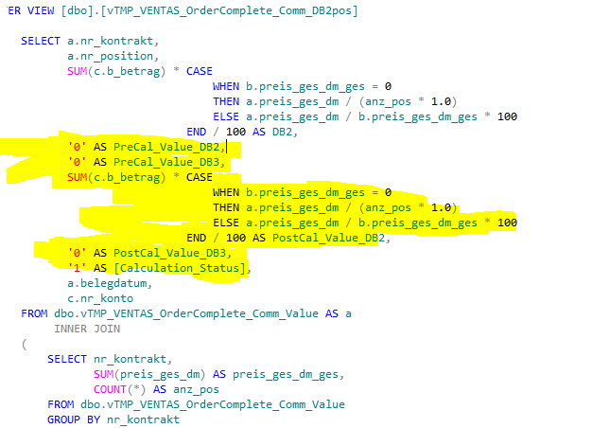

* Change structure view [vTMP_VENTAS_OrderComplete_Comm_Value]

Old Structure New Structure

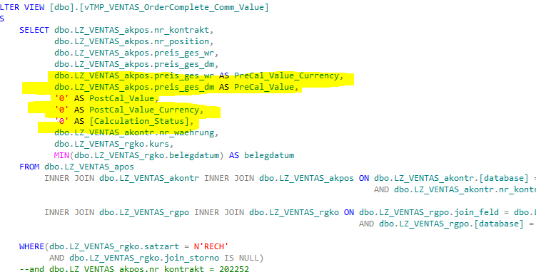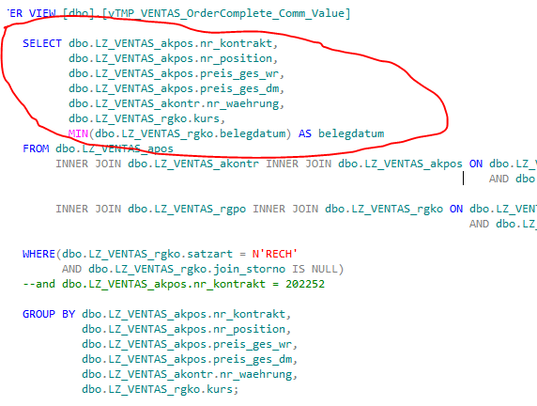

* Change structure view [vTMP_VENTAS_OrderComplete_Trade_DB2pos]

Old Structure New Structure

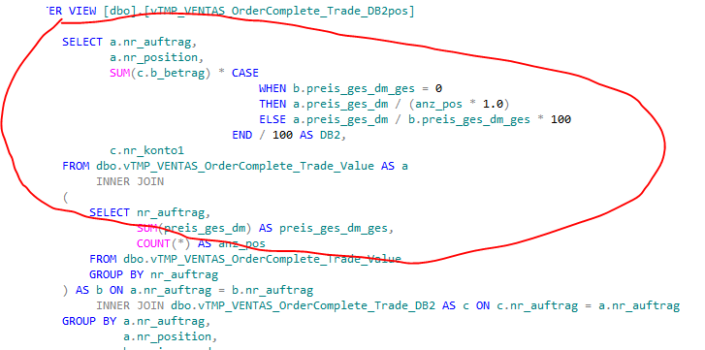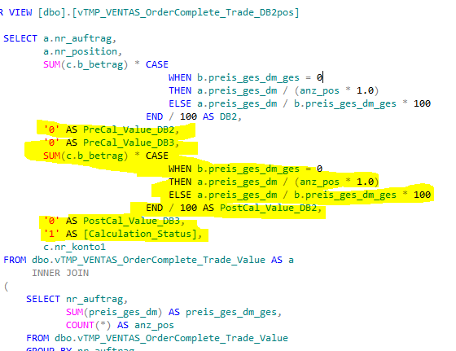

* Change Structure View [vTMP_VENTAS_OrderComplete_Trade_Value]

Old Structure New Structure

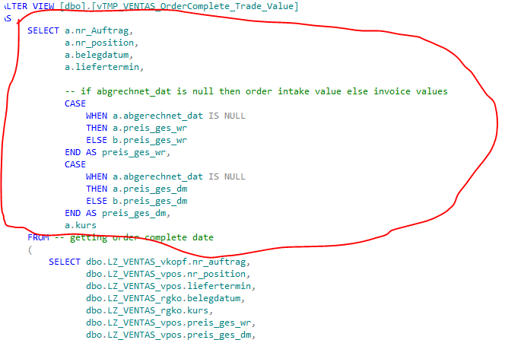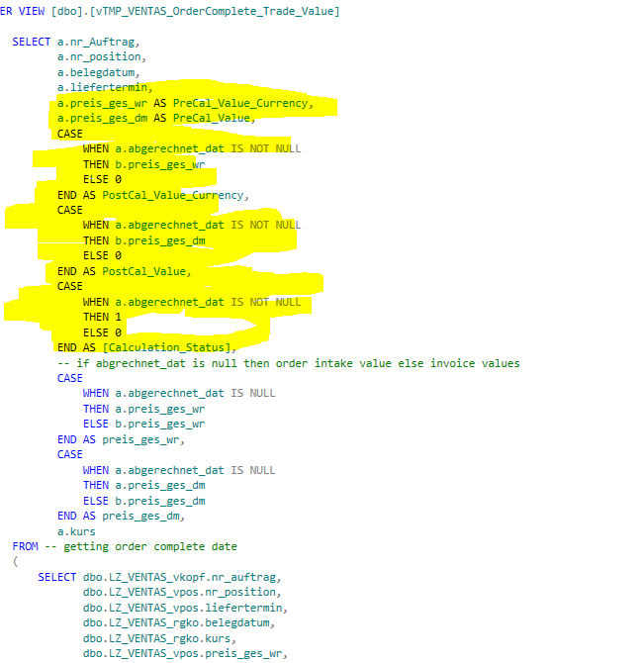

5.1.2. SSIS Package

- Change Source Query Load to Fact from Ventas, Local HKG Orders, LOD-Solomon to FAKT_OrderComplete table and FAKT_OrderComplete_DB2

Old Script Source Query New Script Source Query

 

* 1. Board

1. Test Process
   1. DWH

Local test environment

**Step 1 :**

Clone all structure staging database to Staging_Model Database by using SQL compare

**Step 2:**

Deploy changes structure to Staging_Model

**Step 3:**

Restore database staging as new database with new name StagingTest

**Step 4:** Deploy new structure from Staging_Model to StagingTest

**Step 5:** Run SSIS package Fact_OrderComplete with connecting to StagingTest

**Step 6** :Test Case compare data of StagingTest with Staging



* 1. Board

1. Deployment